**PROCEDURE**

Q1.Write a PL/SQL program to perform banking operations using procedures.

**Program**

create table bank(accno number,name varchar(20),amount number);

insert into bank values(&accno,'&name',&amount);

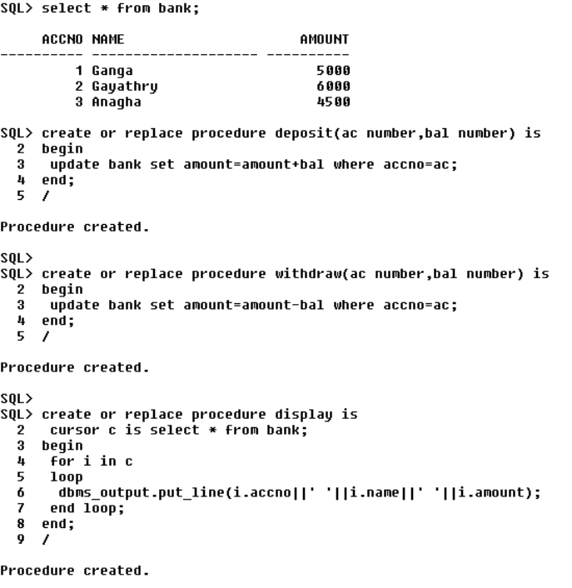

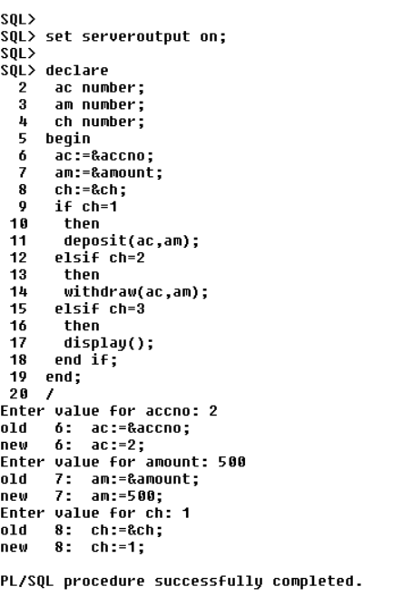

**Output**

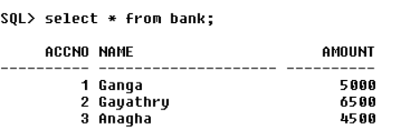

Q2. Selected record's price is incremented by 100, executing the procedure created & displaying the updated table(use user defined Exception).

**Program**

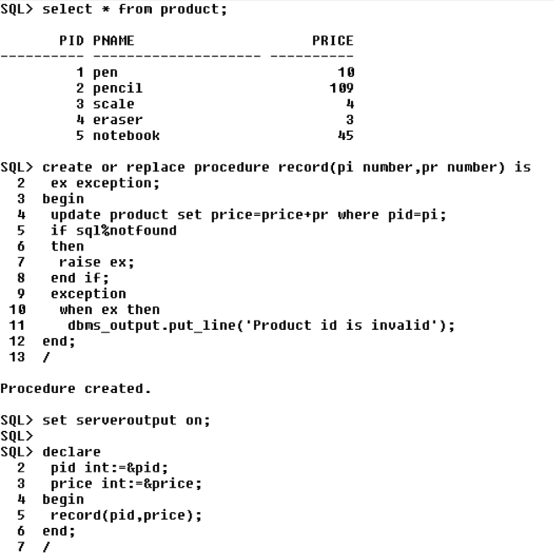

**Output**

